ME270 Kinematics Tutorial

# Step 1: Prepare your SolidWorks model

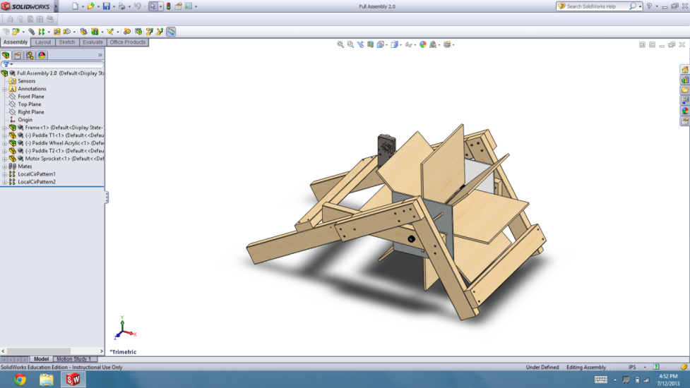To make sure your model is ready to convert, there are a few things that will need to be done.

First, make sure that your model is oriented appropriately. Use the viewing options in Solidworks and check the Front, Top, and Right views to make sure everything is correct.

Next, turn your model such that rotating elements are in the XY plane.

Lastly, suppress any small and unneeded components (small irrelevant screws, bolts, etc.). Too many small complicated parts will slow the system down. If you don’t have very many parts then you don’t need to worry about suppressing anything.

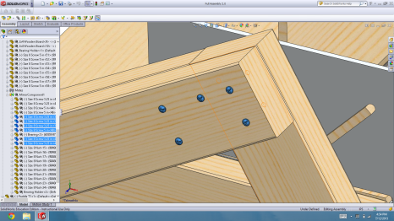

# Step 2: Convert the files

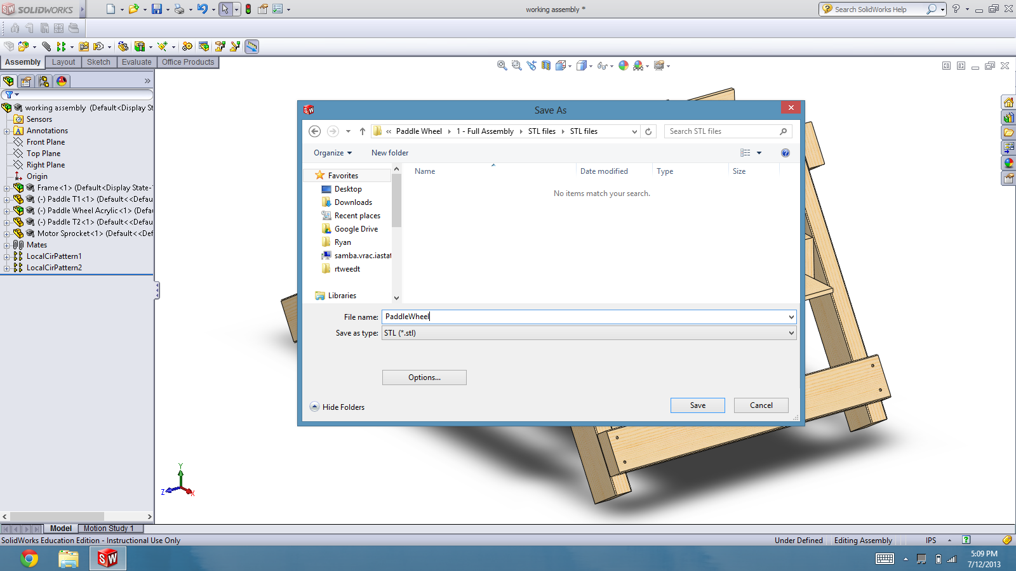Save your model to a new folder as an STL file. This will generate a separate STL file for each component to your assembly.

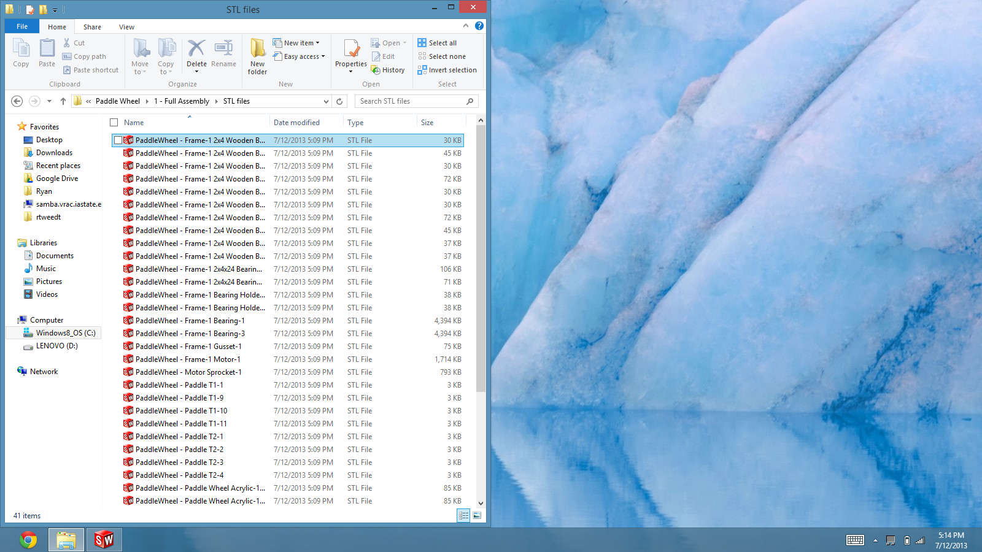

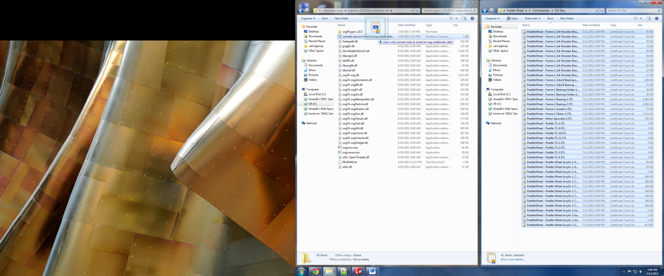

Next, drag and drop all of the new STL files onto the converter. When the conversion is finished, you will have an osg file for every STL file in the same folder. Move all of the osg files to a new folder and rename them if you want. **File names must not contain parentheses.**

# Step 3: Create an input function

Open the file InputTemplate.lua with notepad and follow its instructions.

Done! :D